**Requirement Gathering and Analysis Phase**

**Data Flow Diagram & User Stories**

|  |  |
| --- | --- |
| Date | 04 July 2024 |
| Team ID | SWTID1719939027 |
| Project Name | Project – Book Nest |
| Maximum Marks | 3 |

**Data Flow Diagram:**

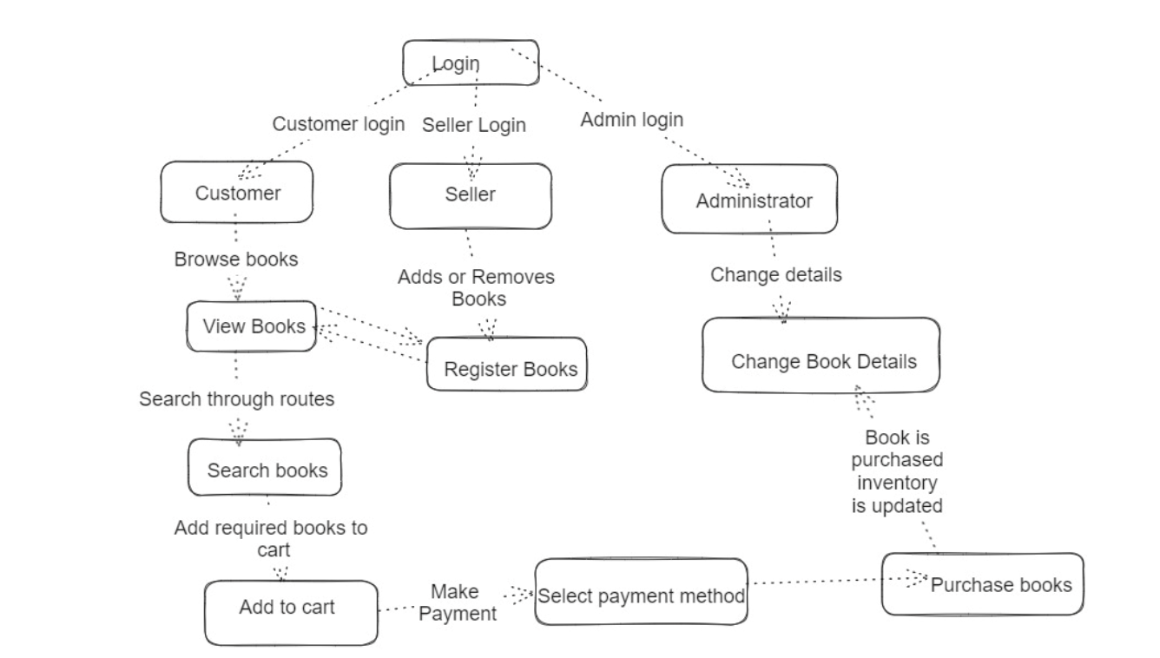

**User Stories**

Use the below template to list all the user stories for the product.

|  |  |  |  |  |  |  |
| --- | --- | --- | --- | --- | --- | --- |
| **User Type** | **Functional Requirement (Epic)** | **User Story Number** | **User Story / Task** | **Acceptance Criteria** | **Priority** | **Release** |
| Customer (Web user) | Registration | USN-1 | As a user, I can register for the application by entering my email, password, and confirming my password. | I can access my account/dashboard | High | Sprint-1 |
|  |  | USN-2 | As a user, I will receive a confirmation email once I have registered for the application. | I can receive confirmation email & click confirm | High | Sprint-1 |
|  |  | USN-4 | As a user, I can register for the application through Gmail. | I can register & access the dashboard with Gmail Login | Medium | Sprint-1 |
|  | Login | USN-5 | As a user, I can log into the application by entering my email & password. | I can log in and access my dashboard | High | Sprint-1 |
|  | Profile Management | USN-7 | As a user, I can access and update my profile information, preferences, and order history. | I can update my profile and see my order history | High | Sprint-2 |
|  | Book Purchase | USN-9 | As a user, I can add books to my cart, specify quantities, and complete purchases securely. | I can add books to my cart, adjust quantities, and purchase securely | High | Sprint-2 |
|  | Selling of Books | USN-10 | As a seller, I can add and sell books. | I can add new books to the catalog and list them for sale | High | Sprint-2 |
|  | Home Page | USN-6 | As a user, I can view the home page which provides an overview of the bookstore's offerings. | I can see a summary of featured books and categories | High | Sprint-3 |
|  | Book Browsing | USN-3 | As a user, I can browse through the available books, explore different genres, and search for titles. | I can browse books by genre, title, or author | High | Sprint-3 |
|  | Admin | USN-14 | As an admin, I can manage all the books and seller info. | I can add, update, or remove book listings and manage seller details | High | Sprint-3 |
|  | Order Confirmation | USN-13 | As a user, I can confirm my order and receive an order confirmation. | I receive an order confirmation once I complete the purchase | High | Sprint-3 |
|  | Book Selection | USN-8 | As a user, I can view a list of available books with details such as title, author, genre, and price. | I can see detailed information about each book in the catalog | High | Sprint-4 |
|  | Additional Book Options | USN-11 | As a user, I can choose additional options such as e-book format or special editions. | I can select and purchase e-books or special editions if available | Medium | Sprint-4 |
|  | Order Management | USN-12 | As a user, I can view my current and past orders, including order status and payment history. | I can track my orders and view payment history | High | Sprint-4 |